HISTORY of REVISION
Rev.  No. | Effective Date | Revised Page (s) | Description | Prepared by | Checked  by | Noted  by | Approved by
01 |  |  | New | DJN | HM | ON | FM
02 |  | 3,13  7,8,9,10,11,12 | Revision of table and Annex 7 for Patlite® Beacon of Process B, Process H2S and Utility  Update New Graphics for Process A, Process B, Process H2S and Utility Alarms | DJN | TY | ME | MK
Prepared by | Checked by | Noted by | Approved by
Dexter J. Navales | Tomoaki Yoneyama | Manabu Enomoto | Munekazu Kawata
Date: | Date: | Date: | Date:
IMPORTANT:
THIS COVER SHEET FORM IS PART OF THE FOLLOWING DOC SHEETS AND IS NOT TO BE DISCARDED UNLESS SUPERCEDE BY A REVISED ISSUE. UNAUTHORIZED REPRODUCTION IS STRICTLY PROHIBITED.

CONTENTS
I. General Description 3
II. Important Monitoring Items 4
1. Controllers’ Description 4
2. Instruments’ Description 4
3. Motors 4
4. Actuated Valves 4
5. Switches 4
1) 000HS901: DCS Common Acknowledge Switch 4
2) 000HS902: DCS Common Reset Switch 5
3) 109HSxxx: 109INT106 Acknowledge Switch 5
4) 109HSxxx: 109INT114 Acknowledge Switch 5
5) 209HSxxx: 209INT214 Acknowledge Switch 5
III. Interlocks/Controls 5
IV. Control Sequences 5
V. Alarms 6
VI. DCS Emergency Shutdown 6
VII. Trend Graphs Grouping 6
Annex 1: CB PROCESS ALARMS A 102 HPAL DCS Graphics 7
Annex 2: CB PROCESS ALARMS A 202 HPAL DCS Graphics 8
Annex 3: CB PROCESS ALARMS B DCS Graphics 9
Annex 4: CB PROCESS ALARMS H2S 1 DCS Graphics 10
Annex 5: CB PROCESS ALARMS H2S 2 DCS Graphics 11
Annex 6: CB UTILITY ALARMS DCS Graphics 12
Annex 7: DCS Room Annunciator Patlite® Beacon and Horn 13

General Description

These graphics screens contain tabulation of critical equipment and instruments with their corresponding normal operating values (under Normal Indication column) and current operating values (under Present Indication column). There are a total of 6 ALARM DCS graphic screens used by DCS operators in the Plant.

During abnormal conditions when the Present Indication of the instrument or equipment is not the same with the Normal Indication of the field, the alarm in the DCS will be activated in order to alert the DCS operator and for him/her to make immediate countermeasure. Alarms in the DCS are both audible and visible alarms which are provided by both the DCS-computer unit and the annunciator - Patlite® in the DCS room. The alarms in the DCS room are classified into 5 main groups; Process A alarms, Process B alarms, Process H2S alarms, Utility alarms and Environment alarms. Each of the five alarms have different Patlite® beacon-horn in order for the DCS operator to easily distinguish the source of the alarm. Refer to Table 1-1 for alarms in DCS.

Table 1-1: Group Alarms in DCS Room
Alarm Group | Graphic Screen | Alarm Area | DCS Room Alarm |  |  | Remarks
Alarm Group | Graphic Screen | Alarm Area | DSC Alarm | Patlite® Beacon* | Horn* | Remarks
Process A Alarms | CB PROCESS ALARMS A 102 HPAL | 102 (HPAL)  103 (PRE-NTRL, CCD)  104 (NTRL) | Audible Alarm | Green Beacon | Sound 1 | Refer to Annex 1
Process A Alarms | CB PROCESS ALARMS A 202 HPAL | 202 (HPAL)  131 (MULTI- PURPOSE)  108 (FNTRL)  114 (FLOC)  115 (NaOH) | Audible Alarm | Green Beacon | Sound 1 | Refer to Annex 2
Process B Alarms | CB PROCESS ALARMS B | 105 (De-Zn)  106 (MS)  111 (L/S) | Audible Alarm | Blue Beacon | Sound 2 | Refer to Annex 3
Process H2S Alarms | CB PROCESS ALARMS H2S 1 | 109 (H2S)  209 (H2S)  Common (H2S) | Audible Alarm | Orange Beacon | Sound 3 | Refer to Annex 4
Process H2S Alarms | CB PROCESS ALARMS H2S 2 | Scrubber (H2S)  Utility (H2S)  Interlock | Audible Alarm | Orange Beacon | Sound 3 | Refer to Annex 5
Utility Alarms | CB UTILITY ALARMS | 416 (ACID)  422 (METHANOL)  513 (WATER)  521 (AIR)  524 (SUPERNATANT)  525 (NITROGEN)  530 (COOLING WATER) | Audible Alarm | White Beacon | Sound 4 | Refer to Annex 6
Environment Alarms | ENVIRONMENT MONITORING | Plant Site environment monitoring instruments | Audible Alarm | Red Beacon | Sound 5 | Refer to TNH-200-103-7

Alarm Group | Graphic Screen | Alarm Area | DCS Room Alarm |  |  | Remarks
Alarm Group | Graphic Screen | Alarm Area | DSC Alarm | Patlite® Beacon* | Horn* | Remarks
Environment Alarms | MS ENVIRONMENT | De-Zn and MS H2S gas detectors | Audible Alarm | Red Beacon | Sound 5 | Refer to TNH-200-103-8
Environment Alarms | H2S ENVIRONMENT | H2S Plant gas detectors | Audible Alarm | Red Beacon | Sound 5 | Refer to TNH-200-103-9

* Refer to Annex 7 for Patlite® Beacon and Alarm

These screens are provided with common acknowledge switch and common reset switch to acknowledge and reset alarms in the DCS room and in the field whenever abnormal operation condition occurs. Furthermore, the CB PROCESS ALARMS H2S 2 has 3 additional interlock acknowledge buttons for acknowledging the three interlock items present in the screen.

Link buttons (► and ◄) are provided for CB Process Alarms A 102 HPAL and CB Process Alarms A 202 HPAL and CB Process Alarms H2S 1 and CB Process Alarms H2S 2. Each alarm screen is provided with link buttons to all of the DCS alarm screens and also link button to Graphic Overview screen is also present.

Important Monitoring Items

Controllers’ Description
None

Instruments’ Description

None

Motors

None

Actuated Valves

None

Switches

000HS901: DCS Common Acknowledge Switch

The common acknowledge (ACK) switch is used by the DCS operator to acknowledge the alarm and silence the audible alarms/horns in the DCS room and in the field. However, the alarm beacon shall remain lighted until the alarm has been reset.


Figure 2-1: 000HS901 – Common Acknowledge Switch

000HS902: DCS Common Reset Switch

The common reset (RESET) switch is used by the DCS operator to reset all the alarms in the DCS. This switch will only function when the alarm value has been restored to normal.

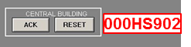
Figure 2-2: 000HS902 – Common Reset Switch

109HS660: 109INT106 Acknowledge Switch

The 109INT106 acknowledge (ACK) switch is used by the DCS operator to acknowledge the alarm and silence the audible alarms/horns in the DCS room when Process Gas Scrubber (109SR01)-Availability becomes an alarm. Refer to TNH-209-103 (5) H2S Waste Gas Treatment DCS Manual.

Figure 2-3: 109HS660 – 109INT106 Acknowledge Switch

109HS658: 109INT114 Acknowledge Switch

The 109INT114 acknowledge (ACK) switch is used by the DCS operator to acknowledge the alarm and silence the audible alarms/horns in the DCS room when Sulfur Blowdown Drum (109VE03) level reaches high high. Refer to TNH-209-103 (4) H2S Purification DCS Manual.

Figure 2-4: 109HS658 – 109INT114 Acknowledge Switch

209HS658: 209INT114 Acknowledge Switch

The 209INT114 acknowledge (ACK) switch is used by the DCS operator to acknowledge the alarm and silence the audible alarms/horns in the DCS room when Sulfur Blowdown Drum (209VE03) level reaches high high. Refer to TNH-209-103 (4) H2S Purification DCS Manual.

Figure 2-5: 209HS658 – 209INT114 Acknowledge Switch

Interlocks/Controls

None

Control Sequences

None

Alarms

None

DCS Emergency Shutdown

None

Trend Graphs Grouping

None

Annex 1: CB PROCESS ALARMS A 102 HPAL DCS Graphics

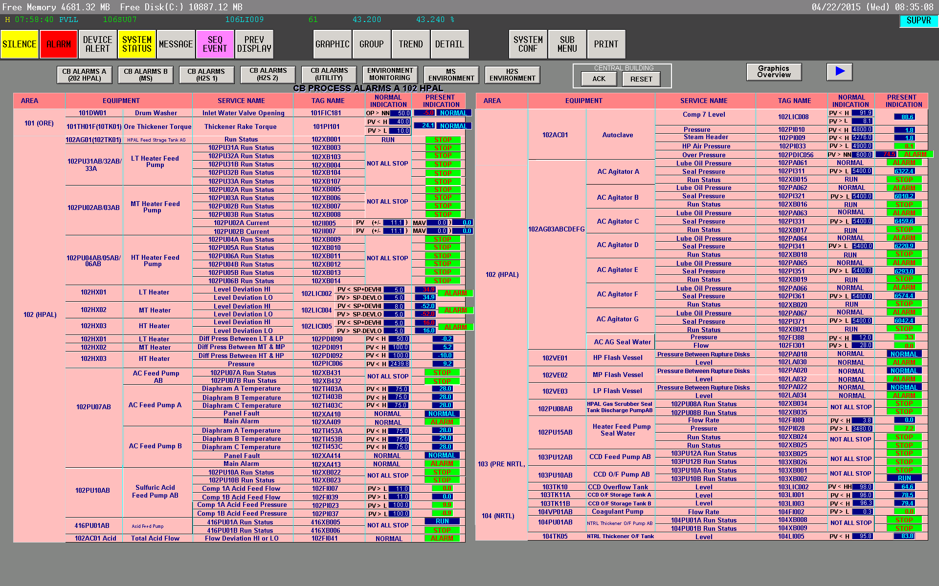
000HS901
000HS902

Annex 2: CB PROCESS ALARMS A 202 HPAL DCS Graphics

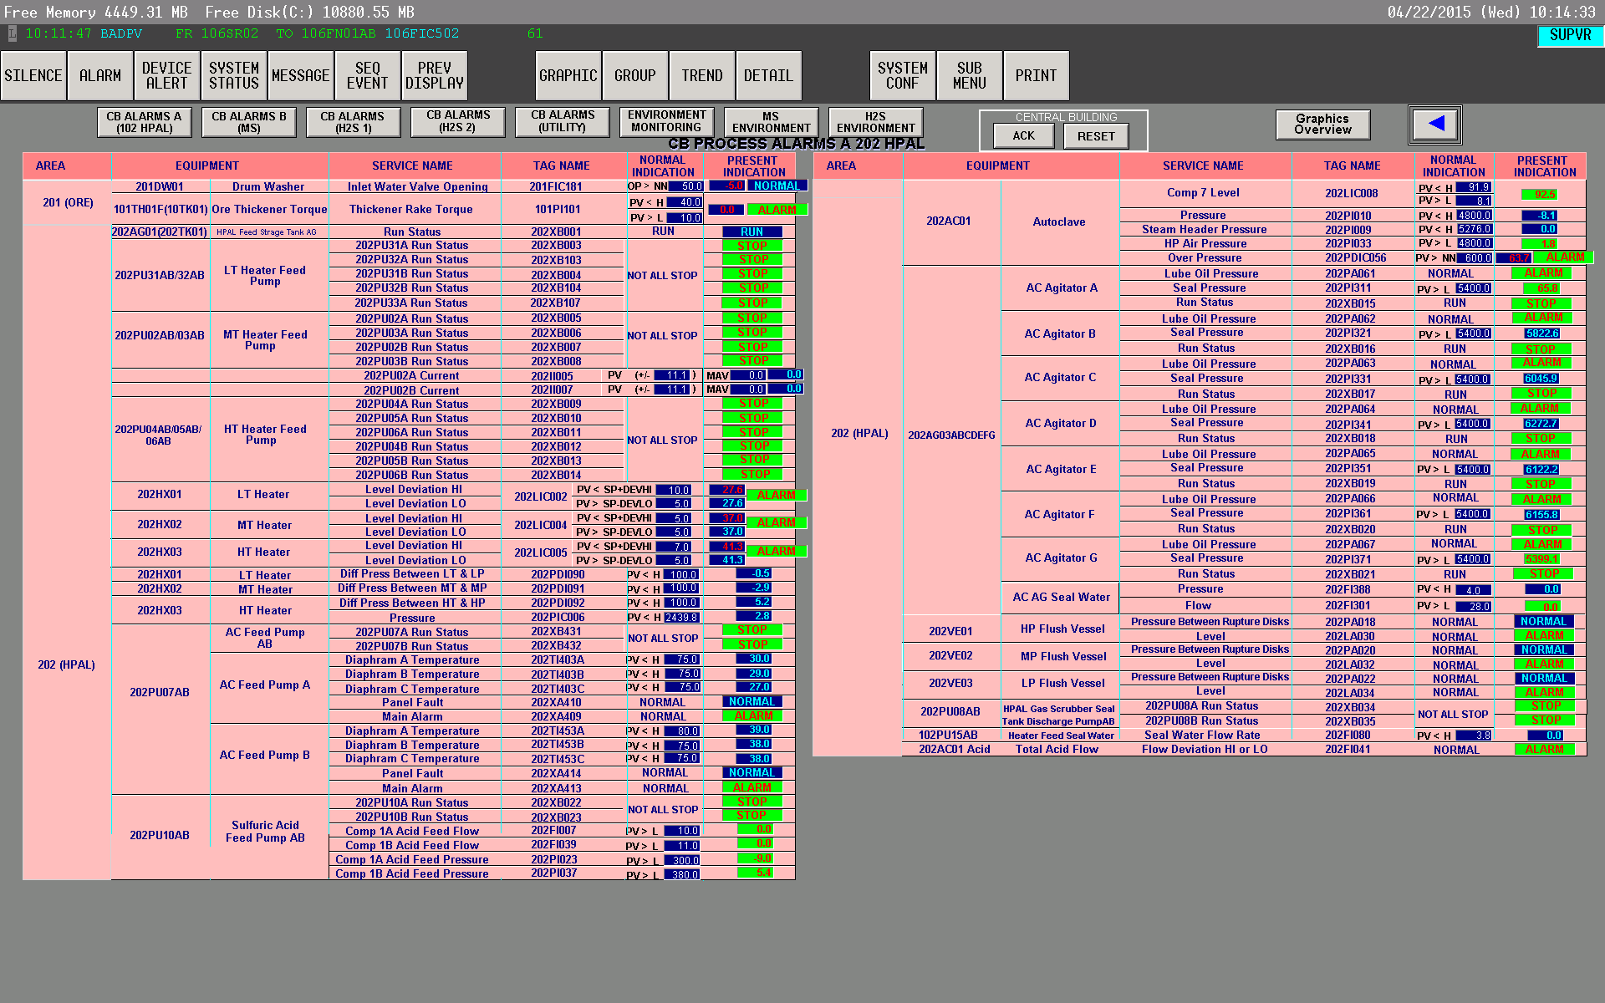
000HS901
000HS902

Annex 3: CB PROCESS ALARMS B DCS Graphics

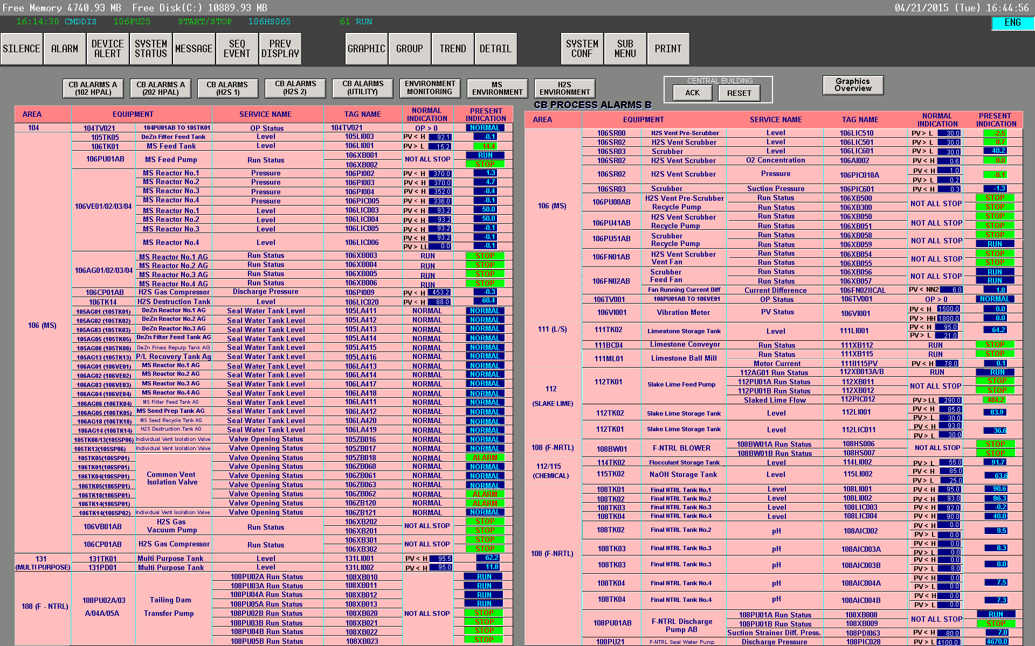
000HS901
000HS902

Annex 4: CB PROCESS ALARMS H2S 1 DCS Graphics

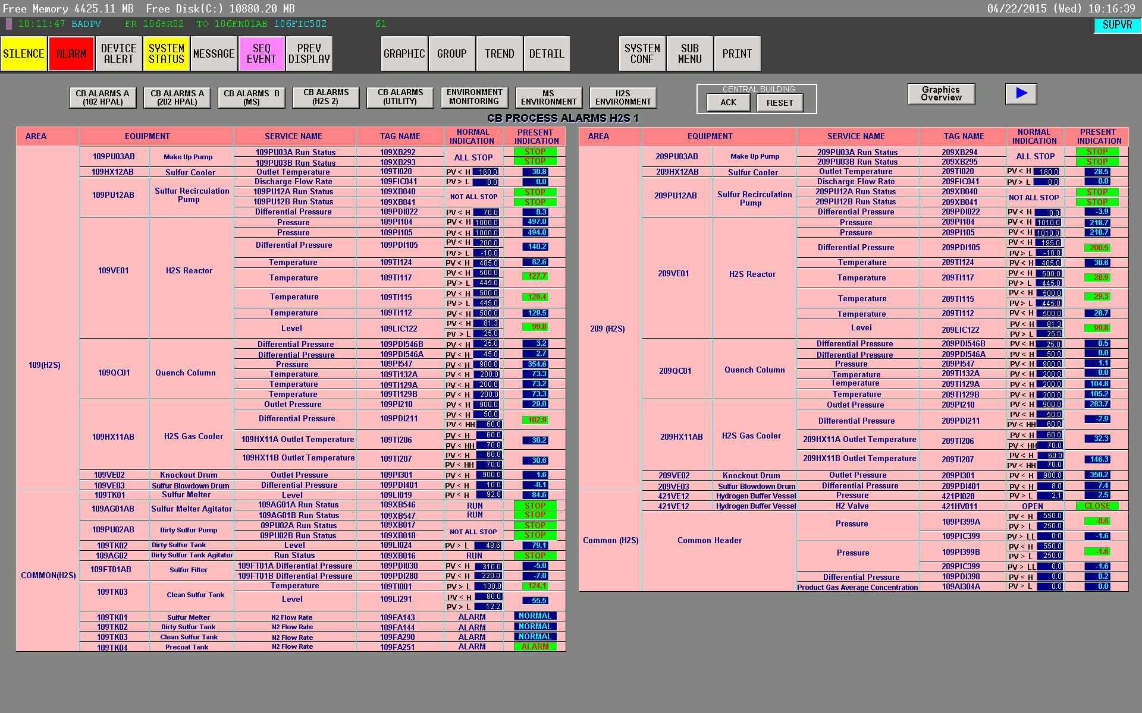
000HS901
000HS902

Annex 5: CB PROCESS ALARMS H2S 2 DCS Graphics

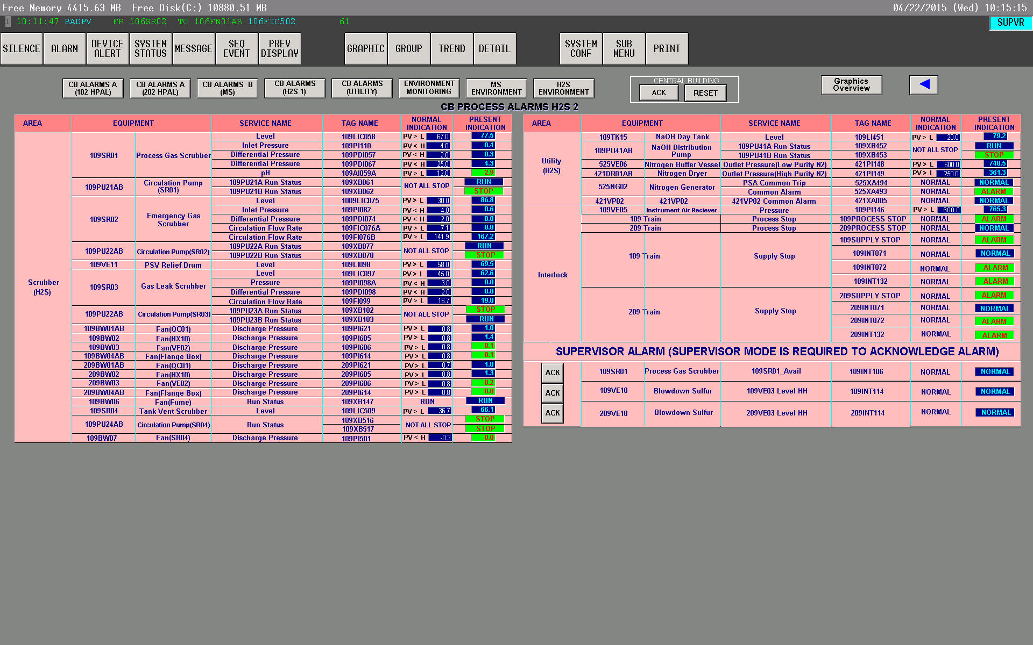
000HS901
109HS660
000HS902
109HS658
209HS658

Annex 6: CB UTILITY ALARMS DCS Graphics

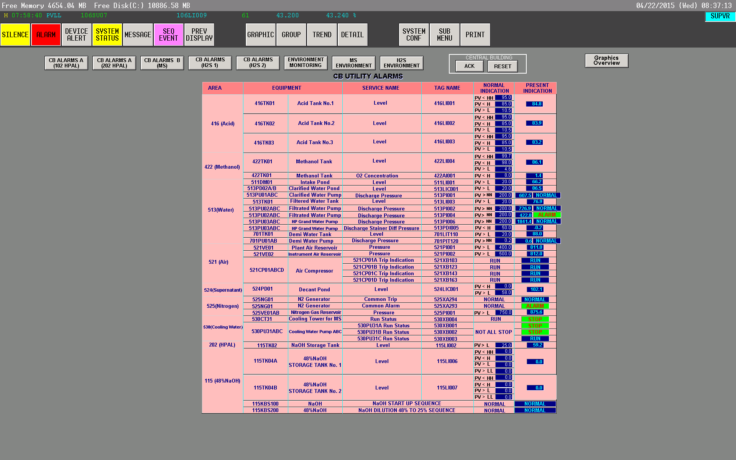
000HS901
000HS902

Annex 7: DCS Room Annunciator Patlite® Beacon and Horn

